Software Requirements Specification
for
Rich’s Rental Cars
Inventory and Customer
Support System
Version 0.1
Prepared by Taylor Earl
9/25/2016

Table of Contents
1. Introduction 1
1.1 Purpose and Intended Audience 1
1.2 Project Scope 1
1.3 Terms, Definitions, and Acronyms 1
1.4 References 2
2. Overall Description 2
2.1 Product Perspective 2
2.2 Product Features 2
2.3 User Classes and Characteristics 2
2.4 Operating Environment 3
2.5 Design and Implementation Constraints 3
2.6 Assumptions and Dependencies 3
3. System Features 3
4. Non-Functional Requirements 4
5. External Interface Requirements 4
5.1 User Interfaces 4
5.2 Hardware Interfaces 4
5.3 Software Interfaces 5
5.4 Communication Interfaces 5
6. Detailed Use Cases 5
7. APPENDIX 10
7.1 APPENDIX A 10
7.2 APPENDIX B 15
7.3 APPENDIX C 17

Revision History
Name | Date | Reason For Changes | Version
Taylor Earl | 9/25/2016 | Initial Document Creation | 0.1
Taylor Earl | 10/1/2016 | Added Use Case section along with other changes. | 0.2

Introduction
Rich N’ Famous Rental Cars is a car rental company that provides all ranges of rental cars to their clients. Rich Fry, the owner of the company, along with his stakeholders have decided that they need to update to a modern system that will help them increase sales, simplify the tasks of staff across all positions in the company, and keep better track of inventory from a corporate level. The system will help solve these problems by giving Rich a brand new user interface that will simplify the tasks his staff need to do, create an online presence that will bring his company into the “technical” age in turn helping to boost not only visibility to his company but also sales, and implement a system to utilize the barcode scanners Rich already has to quickly scan cars in and out of their lots.

Purpose and Intended Audience
This document has been created to detail the system that has been requested for the company Rich N’ Famous Rental Cars. This document will list all objectives that will be accomplished when the project has been completed. It is available for Rich Fry and his Stakeholders to view so they know what can be expected along with the team of Software Engineers that will be working on this project so that they know what is expected from them.

Project Scope
This system will allow the staff of Rich N’ Famous Rental Cars to enter and track inventory and customer billing records. Customers will be able to interact with this system using the internet, while the staff of Rich N’ Famous Rental Cars will be able to interact from a back end interface. Other than Inventory, Customer, and Billing information, no other company information will be accessible through the program.

Terms, Definitions, and Acronyms
- Database: A place to record and reference a set of data.
- DBMS (Database Management System): The software that will be used to access, manipulate, and organize the information that has been entered into the database.
- E-Commerce: A system that allows end users to pay for things via credit/debit cards.
- RNFRC (Rich N’ Famous Rental Cars): The company requesting the software.
- Scanner: Devices used to scan barcodes.
- Stakeholder: Non-programmers that are interested in the development of the system.

References
Fry, R. Rich n’ Famous Rental Car Scenario. Appendix A
Fry, R. (2016, September 25). Rich N’ Famous Car Rental – Questions to the client Appendix B
Rich N’ Famous Client Comments [Video] Appendix C

Overall Description

Product Perspective
There will be a few external systems needed to run the program. A DBMS will help staff add to and access the various inventory, customer, and insurance information. A web server will also be needed to host the new website that will be constructed for customers to use. Inside of the website, the e-commerce system will be implemented so that customers can use their cards to pay for rentals.
Payment
Processing

Product Features
This system will be able to:
- Store various information about Vehicles
  - Pictures, price, lot, availability, maintenance records
- Customers will be able to view available cars and rent them online
- Customer Membership program that is determined by how much they rent
- Build reports and spreadsheets with data that has been entered into the system
- Allow staff to scan vehicles into system and have status updated
- Calculates price of rental based on many variables
  - Insurance selected, member of customer program, late rentals, damage to vehicle
- Status of all current rentals, including late rentals

User Classes and Characteristics
Customers will need to know how to access the website via phone or computer. The site will be laid out in a very simple way, so if they can shop online they will be able to rent a car. Employees will need to be able to use the site also. They will also need to know computer basics. If they are proficient with the Microsoft Office suite, they will be able to operate the system. Clerks will need to know how to navigate the e-commerce system to charge customers and also give them refunds when applicable.

Operating Environment
Customers and employees will be able to access the system via the internet. Other than that, each location will be able to access the system. A minimum of one computer will be required, but a computer for the clerks, maintenance, and management could be implemented also.

Design and Implementation Constraints
Employee information will not be recorded and kept inside of the system. No integration with the state DMV will be provided. A minimum amount of customer insurance information will be recorded. (Information vital to an insurance claim)

Assumptions and Dependencies
The system will be completed by Mid-December at the latest, in time for the Holiday Season. Scanners have been purchased and were paid for in the previous fiscal year, and do not need to be worried about, just integrated into the system. Internet connectivity is present at all locations already along with computers for the staff to access and use.

System Features
Owner
- Email Alert when a vehicle has expired

Managers & Owner
- Add, remove, and modify cars from inventory list
- Add, remove, and modify user permissions for staff accounts
- Email Alert when inventory stock is low
- Sales total override
- Pull vehicle revenue reports per location
- All other employee actions

Clerks
- Access and modify all reservation records
- Create and update client accounts
- Check vehicles in and out
- Pull reports
- Scan vehicle barcodes into the system

Maintenance
- Pull maintenance records for a car
- Scan a car to enter records

Legal
- Run claims reports
- Enter and modify claim information
Customers
- View inventory catalog per location
- Reserve cars from website
  - Select insurance option
  - Pay for rental
- Sign up for Membership program
- Agree to Terms/Conditions

Non-Functional Requirements
Functionality
- Save time with less steps to accomplish a given task
Usability
- Modern User UI
- Work on all mobile and desktop browser
- Responsive website
Reliability
- Safeguards to prevent the server from going down
- Data is backed up to server right after being entered
- Possibility for data back ups
Performance
- Information will be available 24/7 via online website
- Databases will sync on a regular time interval
- Reports will run quickly
Supportability
- System maintenance will be done during low traffic times
- Basic troubleshooting will be taught to managers
- Support when necessary

External Interface Requirements

User Interfaces
This section describes any external system user interfaces that may be required by the system, e.g., a console window.

Hardware Interfaces
This section describes any external system hardware interfaces, e.g., an analog to digital converter that may be required by the system.

Software Interfaces
This section describes any external software interfaces, e.g., input files to this system that were created by another software system.

Communication Interfaces
This section describes any external communication interfaces, e.g., TCP/IP communication sockets that are necessary for the operation of this system.

Detailed Use Cases
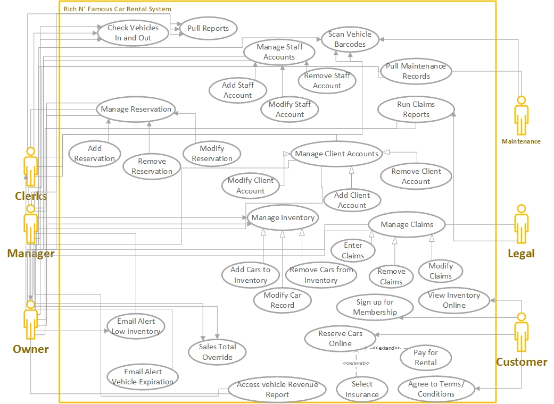

FIGURE 6.1: Rich N’ Famous Car Rental System Use Case Diagram

Illustrates the relationship between different user groups and functions of the system.

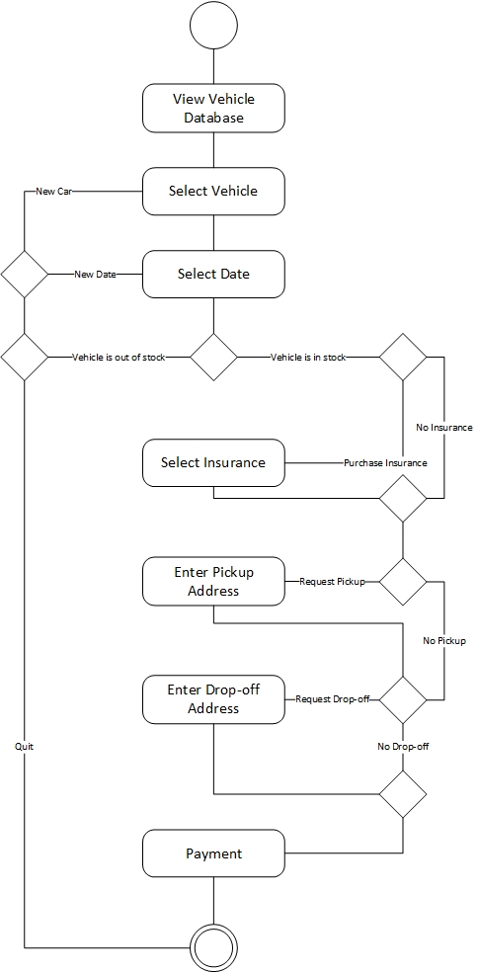

FIGURE 6.2: Customer Vehicle Reservation Activity Diagram

The process in which a customer will go through when renting a vehicle.

Use case name: Reserve Vehicle | ID: 1 | Importance Level: High
Primary actor: Customer | Use case type: Detailed, Essential
Stakeholders and interests:
Customer- will have a way to select vehicles based on location and date for online reservation
Owner- wants to provide customers with a simple way to reserve vehicles

Brief description: Explanation of steps necessary for customer to rent a vehicle via website

Trigger: Customer needs to rent a vehicle and doesn’t want to call or visit store to make reservation

Relationships:
Association: Customer
Include:
Extend: Select Insurance, Pay for Rental
Generalization:

Normal flow of events:

- Customer goes to website and sees vehicle database
- Customer chooses a vehicle
- Customer inputs date for reservation
If the vehicle isn’t available, the customer enters a new date
S-1: New Date sub flow is initialized
If the vehicle isn’t available, the customer chooses a new vehicle
S-2: New Vehicle sub flow is initialized
- Does customer want insurance?
If yes, customer selects insurance
- Does customer want to pick-up?
If yes, customer inputs pick-up location
- Does customer want to drop-off?
If yes, customer inputs drop-off location
- Customer Pays
Subflows:
S-1: New Date
1: Customer goes back to step 4
2: Customer enters a new date

S-2: New Vehicle
1: Customer goes back to step 3
2: Customer chooses a new vehicle

Alternate/exceptional flows:
S-1 B1: Customer can’t find a vehicle they like
S-1 B2: Customer exits program

S2- B1 Customer can’t find a vehicle on requested date
S2- B2: Customer exits program

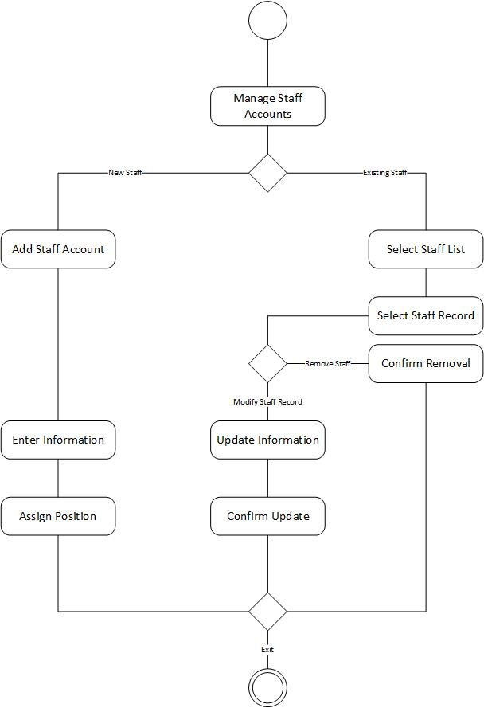

FIGURE 6.3: Staff Record Management

The process in which the owner or manager will go through when managing a staff record.

Use case name: Staff Account Management | ID: 2 | Importance Level: High
Primary actor: Manager, Owner | Use case type: Detailed, Essential
Stakeholders and interests:
Owner, Manager – will have a way to enter, modify, and remove staff records when necessary.

Brief description: Explained process of how to manage staff records.

Trigger: Employee is hired, updates information, or leaves company.

Relationships:
Association: Manager, Owner
Include:
Extend:
Generalization:

Normal flow of events:
- Owner or Manager opens staff account management
- Owner or Manager chooses to enter new staff, or modify existing.
If enter new staff is selected
S-1: Add new staff
If modify existing is selected
S-2: Modify existing Record
- Exit staff account management

Subflows:
S-1: Add new staff
- Enter appropriate information
- Assign position
S-2: Modify Existing Record
- Select staff from list
- Choose to modify staff record or remove staff record
If remove staff record is selected
S-3: Remove Staff Record
If modify staff record is selected
S-4: Modify Staff Record

S-3: Remove Staff Record
- Confirm Removal

S-4: Modify Staff Record
- Update Information
- Confirm Update

Alternate/exceptional flows:
1a1: Owner or Manager cannot log into system.

APPENDIX

APPENDIX A

Rich n’ Famous Rental Car
Scenario for CS 2450 Homework 2-9
To keep up with the competition, Rich n’ Famous Rental Car (a small but growing Utah business with six locations and annual profits totaling approximately $100,000) wants to automate their rental system. The owner (and manager) of the main Salt Lake City branch is Rich Fry.
Rich would like to upgrade his current manually processed system to something “21st century”. He sees his competition using mobile handheld laser scanners with a built in keypads, credit card swipes, LCD Screens, and Thermal Printers. He believes these scanners utilize wireless technology to communicate with a computer terminal/database, but is unsure of the details of how they work. It is Rich’s goal that by having his rental clerks and maintenance personnel use something similar to these mobile scanners at each rental location, they will be able to better track the status of each rental vehicle on the lot (or out for a reservation/repairs/etc.). As an added bonus, storing data electronically will allow Rich (as the owner) to track each vehicle from the moment he acquires it for use in his business and assigns it to one of his lots as a rental item. He hopes to better track each vehicle’s revenue and expense history (how many times was the vehicle rented, how much revenue did the rental make, and how much did it cost him to maintain it?) Among other things, he would also like for his managers to know any accident reports or insurance claims associated with the vehicle they are in charge of renting. Managers and clerks should have access to all aspects of the current reservation information on each vehicle (with varying permissions). Finally, since Rich only basically keeps his rentals for approximately 1 year or 20,000 miles, before disposing of them at auction (and buying new inventory), he would like to have a report flagging when vehicles are reaching their “expiration” date.
Rich also feels that the Internet offers further exciting opportunities for increasing efficiency and reducing costs. For example, rather than printing catalogs of available cars, he could make the catalog available to every Internet surfer for browsing on-line. For privileged customers, he could provide extra services, such as discounts, or advanced reservations of special vehicle types. Using the full power of e- commerce, he aims to offer all our services via a Web browser, with delivery and pick up at the customer’s home (bringing them back to our site to check out), thus achieving his ultimate goal of the virtual rental company, with minimal running costs relative to walk-in stores. His target saving in this area is a reduction of 15% in the cost of running each store, effective the first year the website is up. Through market research, he also believes the Internet will eventually him achieve double his current annual sales within the next 5 years.
Some General Business Rules follow on the next pages….(you’ll be able to gather more by asking the client more specific questions in class):

Employees

We have one manager at each of our 6 locations in Utah. Rich is a manager at the main location in Salt Lake City, and also the owner of the business.
We have several clerks at each location who work on-site 24 hours a day, 7 days a week. The clerks are responsible for a variety of duties, including making reservations for a client who calls or walks in, updating, and cancelling reservations from an on-site terminal (computer that needs upgrading). They are also responsible for checking a vehicle in and out of the lot (or transferring to another lot) as well as generating several reports (primarily daily reservation and missing vehicle / accident reports). They are currently using a basic spreadsheet to do all this.
We also have several maintenance personnel who are responsible for (at a minimum) for washing and vacuuming the vehicles when they are returned on-site. The maintenance people are also in charge of performing periodic (oil changes, tire rotations, safety checks, general repairs) on vehicles, based on a pre-determined maintenance schedule. This maintenance is an “expense” to the business and must be better accounted for and managed. There needs to be some way for employees to generate maintenance service reports on each vehicle, and to record the associated expenses involved with each vehicle maintenance as they perform work. Currently, this is not in place.
Finally, we have legal personnel (at the main office only) who are responsible for filing and tracking insurance claims with our private 3rd party insurance firm, for all vehicles on all lots that are not covered by a renter’s policy. Currently this coordination is all done by phone calls between the lots and legal staff. While legal is responsible for filing and monitoring missing vehicle reports and claims, it is the clerk who spends the first 24 hours trying to personally contact the renter, before legal proceedings are officially begun – when a vehicle is more than 24 hours overdue). See below. Legal needs tracking reports to monitor claims. Currently they use a spreadsheet only.

Vehicles

- Car availability and status information (including active lot inventory, acquisition and disposal history, rental reservation history, periodic vehicle maintenance, insurance claims, and vehicle accident reports) is currently tracked individually at each location, but should be centralized.
- Each vehicle is typically assigned to one rental location only and is tracked by its unique VIN#. All information about a vehicle is available to management (at their own sites – the owner, of course has access to all information.
- When a new car is acquisitioned in inventory (purchased by the owner for use at each site), it is delivered and received on-site.
- Records are made in a spreadsheet every time a vehicle arrives or departs the site. Same with when a vehicle is checked in/out for maintenance, and by the legal department. None of the systems “talk” to each other.
- Once a reservation is billed (completed), or cancelled, the car is placed back in available inventory (unless it is damaged). Cancelled cars (not driven) are placed directly back in active inventory. Driven (billed) cars need to always first go to maintenance for a car wash (and perhaps other maintenance).
- When a car is returned, it is inspected, tire pressure checked, washed, and either returned to inventory or remains in maintenance for periodic maintenance (see below).
- If a rental is more than 24 hours overdue, the clerk spends the next 24 hours trying to contact the customer. If the customer does not respond, the clerk files a report with the legal department, which begins a process of notifying the authorities, and 3rd party insurance that the vehicle is missing.
- A wrecked (damaged) car or a car that breaks down will also require additional reports and tracking with 3rd party insurance, and will be transferred to legal for tracking purposes using the same process. Once resolved, the vehicle may be returned to the rental inventory.
- All cars must be returned to their original rental location (because of inventory purposes)…but we want to be able to share inventory between lots.
- Periodic maintenance is done, in house, via a group of maintenance workers – including oil changes every 3000 miles, and more, based on a pre-determined database table of scheduled maintenance (which depends on the actual vehicle type).
- Here is an example of scheduled maintenance (not inclusive) which the technician is able to add/delete/and update the master list.
Vehicle Type | Maintenance | Frequency | Cost
All | Car Wash and  Vacuum | Every time an undamaged vehicle returns to the lot | $25
Standard Cars | Oil Change | Every 3000 miles | $30
High Performance or  Specialty Cars | Synthetic Oil  Change | Every 7500 miles | $60
Industrial Trucks | Oil Change | Every 4000 miles | $50
All | Tire Rotation | Every 10,000 miles | $50
All | Repairs | As Needed – based on notes provided by the rental clerk checking the vehicle in, or notes made by the maintenance personnel once the vehicle is examined in the shop. | $50 per hour plus parts
- Vehicles more than one year old (or 20,000 miles) are sold by the owner to an auto auctioning facility and removed from the inventory. Management notifies the owner when vehicles are getting ready for auction.
- Vehicles are acquisitioned for Rich’s rental company through a 3rd party contract with Fleet Rental Services. The owner performs this function.
- A printed catalog is currently the only way to for someone to see available vehicles, prices and descriptions. We need a website.
- We hope to allow a member to sign up to be a preferred member and received advanced notifications for special vehicles and rental discounts. Our ideas are below.
- Insurance options will affect the disposition of the vehicle, if it is wrecked or damaged.

Customers

- A Customer can rent a car in store (through a rental clerk) or by phone. However, all reservations require a credit card, and have a 24 hour cancellation policy.
- A customer is offered our 3rd party insurance at the time of PICKING UP the reservation. If the insurance is declined, a major credit card is required (no debit or cash) when the rental is returned and finally billed. Upon return, if cash or debt is used (only applicable to customers who purchased our insurance), the customer will need to go inside the office to settle the payment. However, if the customer prefers to charge the final bill to the credit card, then this should be able to be done from a mobile scanner with making the customer come inside.
- If a customer buys our insurance, it relieves them for all liability, except for a $500 deductible, when the damage is NOT due to customer negligence (like drunk or wreck less driving). If negligence is involved, then the car is turned over to legal for insurance processing.
- Insurance processing is a 3rd party service that goes after a driver’s personal insurance or credit card insurance on our behalf. However, the legal department must still file the claim, and have the ability to monitor and track its status.
- A Customer can sign up to be a preferred member to qualify for discounts and special offers.
- A Customer must provide a valid credit card, US driver’s license, and proof of address to become a member. This information is used to contact the each of the 50 State’s DMVs for the driver’s records. The DMV must return a “good” or better driving status in order for the customer to be considered a preferred member for a particular rental.
- Preferred members automatically receive a 10% discount off all rentals and their 10th rental is free (for up to 3 days). If the 10th rental happens to be more than three days, than the prorated discount is applied.
- Before the 10% is offered, the DMV check will be made again when the car is PICKED UP (to ensure the customer’s drive record is still “good” since they signed up as a preferred member). • A preferred member’s DMV status is checked prior to each rental PICK UP by passing in the Driver’s License number and State (any of the 50). The DMV returns a “Valid” license status and a driving record status. If the DMV driving record status drops below “good” (on an Excellent, Good, Fair, Poor scale) then the preferred status is revoked for THIS rental, and this particular
rental will not receive a discount or credit towards the 10th rental nor will he receive the 10% discount (even if the reservation was previously made via the Internet). Consequently, people without a United States driver’s license do not qualify for this preferred membership, as there is no way to check DMV records internationally.
- If the DMV ever returns an “Invalid” license – then we do not rent the vehicle. No matter if a customer is preferred or not, we always run a valid check (we only do an additional Status Check for preferred members) with the DMV to determine if the driver’s license is still active. Obviously, we do not have this feature for driver’s coming from out of country, and for the meantime, this is a manual (visual) verification.
Any reservation can be cancelled by phone, in person, (and hopefully) the Internet. But, a customer is billed for one day’s rental if they have not cancelled the reservation within 24 hours or the scheduled pickup, or fail to pick up the vehicle at all.

APPENDIX B

RICH N’ FAMOUS RENTAL CAR – QUESTIONS TO THE CLIENT

THOMAS BRUSCH
9/6/2016

Dear client,

Is there a desired completion date?

ALISON SUNDERLAND
9/6/2016

Yes, it should be up and running for the Christmas holiday season. Mid December at the latest.

---------------------------------------------------------------------------------------------------------------------

ERIC TINAJERO
9/12/2016

Dear Client,

What are the data fields you are currently using in your maintenance and inventory spreadsheets?

ALISON SUNDERLAND
9/12/2016

That is an excellent question. We can give you a comprehensive list of the data fields once your development company has won the contract for this proposed system (unless you are required to come up with them in a future assignment...) :)

---------------------------------------------------------------------------------------------------------------------

DONNA TAYLOR
9/16/2016

Dear Client,

How many cars are in inventory at each location?

How much is the average profit per rental?

How many rentals in an average month?

What the operating costs are for each location?

Are you open to shutting down one or more locations if moving toward more of a home-delivery format is successful enough to warrant it?

ALISON SUNDERLAND
9/17/2016

How many cars are in inventory at each location?
Approximately 12.

How much is the average profit per rental?
Based on the purchase price, the selling price, maintenance/upkeep fees, and the rental income our profit is roughly 160% – 180% over the life of a vehicle

How many rentals in an average month?
On average, 75% - 80% of our inventory is rented out at any given time.

What the operating costs are for each location?
we spend about 145K in labor costs per location and an additional 40K per location in other operating costs. The maintenance costs run about 12K a year per location.

Are you open to shutting down one or more locations if moving toward more of a home-delivery format is successful enough to warrant it?
We had not considered that. But it is something we should will have to discuss based on the price of upkeep for each location and the cost of transporting within our service area.

---------------------------------------------------------------------------------------------------------------------

WILLIAM BURK
9/17/2016

Dear Client,

You mentioned that you had already purchased several computers and PCs, and Laser Scanners. What were your total expenditures for these purchases?

ALISON SUNDERLAND
9/17/2016

We have 3 scanners per location. We spend approximately $250 per scanner. As for the rest of the hardware, we bought it last fiscal year so it does not impact the current fiscal year.

---------------------------------------------------------------------------------------------------------------------

WILLIAM BURK
9/23/2016

Dear Client,

Is there a specific name you would like us to give to this Project?

APPENDIX C

The provided video file has been uploaded privately to YouTube so anyone that follows the link below will be able to view.

https://www.youtube.com/watch?v=ExrzPfbpc1o

